**Mobile Controlled Robot**

**Project Exhibition -1**

Submitted in partial fulfillment for the award of the degree of

**Bachelor of Technology**

**In**

**MECHANICAL ENGINEERING**

Submitted to

**VIT BHOPAL UNIVERSITY (M.P.)**



**Submitted by**

**DIVYA KHANOLKAR (17BME10035)**

Under the Supervision of

**DR.RIBU MATHEW**

**SCHOOL OF MECHANICAL ENGINEERING**

**VIT BHOPAL UNIVERSITY**

**BHOPAL (M.P.)-466114**

**December-2018**



**VIT BHOPAL UNIVERSITY BHOPAL (M.P) 466114**

SCHOOL OF MECHANICAL ENGINEERING

**CANDIDATE’S DECLARATION**

I hereby declare that the Dissertation entitled “**Mobile Controlled Robot**" is my own work conducted under the supervision of Dr. Ribu Mathew, Assistant Professor, School of electrical and electronics engineering at VIT University, Bhopal.

We further declare that to the best of our knowledge this report does not contain any part of work that has been submitted for the award of any degree either in this university or in other university / Deemed University without proper citation.

Divya Khanolkar

(17BME10035)

This is to certify that the above statement made by the candidate is correct to the best of my knowledge.

Date: _______________

Dr. Ribu Mathew

Assistant Professor



**VIT UNIVERSITY BHOPAL (M.P.) – 466114**

SCHOOL OF MECHANICAL ENGINEERING

**CERTIFICATE**

This is to certify that the work embodied in this Project Exhibition -1 report entitled **“Mobile Controlled Robot”** has been satisfactorily completed by **Ms.Divya Khanolkar (17BME10035)** in the School of Mechanical Engineering of 2nd year at VIT University, Bhopal. This work is a bonfire piece of work, carried out under my/our guidance in the School of Mechanical Engineeringfor the partial fulfilment of the degree of Bachelor of Technology.

**Dr. Ribu Mathew**

**Assistant Professor**

Forwarded by Approved by

**Dr. Pritesh Vishwasrao Bansod Dr. Francis Xavier**

Program Chair Professor & Dean

**Acknowledgement**

I would like to express our special thanks of gratitude to our Program Chair ***(Dr. Pritesh Vishwasrao Bansod)***as well as our Dean **(*Dr. Francis Xavier)***who gave me the golden opportunity to do this wonderful project based on DTMF and basic robotics*,* which also helped me in doing a lot of research and I came to know about so many new things. I am really thankful to them.

I am thankful to our guide, ***Dr. Ribu Matthew*** for giving me valuable inputs and helping me in the development of this project. I also thank lab technician Ajab Singh sir and other non teaching staff for their help during the development of this project.

Secondly I would also like to thank my parents and friends who helped me a lot in finalizing this project within the given time frame.

**Executive Summary**

DTMF Mobile Robot is a machine that can be controlled with a mobile. In this project, the robot is controlled by a mobile phone that makes a call to the mobile phone attached to the robot. In the course of a call, if any button is pressed, a tone corresponding to the button pressed is heard at the other end of the call. This tone is called "Dual Tone Multiple-Frequency" (DTMF) tone. DTMF technology is most useful technique at present days. It is worked on to methods digital signal processing (DSP). Wireless-control of robots uses RF circuit that has the drawbacks of limited working range and limited control. This DTMF is gives advantage over the RF; it increases the range of working and also gives good results in case of motion and direction of robot using mobile phone through micro controller. This type of wireless communication gives the remote handling operation of Robot using DTMF.

**List of Figures**

|  |  |  |
| --- | --- | --- |
| Figure No. | Caption / Title | Page No. |
| 1.1 | Circuit Image | 11 |
| 1.2 | Circuit Diagram | 13 |
| 1.3 | DTMF table | 15 |
| 3.1 | Diode | 18 |
| 3.2 | Resistor | 19 |
| 3.3 | Capacitor | 20 |
| 3.4 | LM780 | 21 |
| 3.5 | Left Hand Rule | 22 |
| 3.6 | Crystal Oscillator | 23 |
| 4.1 | Working Model | 26 |
| 4.2 | Block Diagram | 28 |

**List of Symbols & Abbreviations**

DTMF**-**Dual Tone Multifrequency

AVR- Alf & Vegards

RISC- Reduced Instruction Set Computer

dB- Decibels

LED- Light Emitting Diode

DC/AC- Direct Current/Alternate Current

Amp- Ampere

pF- Picofarad

PPM-Parts Per Million

**Table of Contents**

Front Page 1

Candidate’s Declaration 2

Certificate 3

Acknowledgement 4

Executive Summary 5

List of Figures 6

List of Symbols & Abbreviations 7

Contents Page No

1. **INTRODUCTION 10**
   1. **Motivation 10**
   2. **Introduction 10**
   3. **Objective 11**
   4. **Methodology 11**

**1.4.1 Circuit Design 12**

**1.4.2 Working 13**

**2 LITERATURE SURVEY 16**

**3 COMPONENTS USED 18**

**4 RESULT AND DISCUSSION 26**

**5 CONCLUSION 30**

**6 FUTURE SCOPES 31**

**9 REFERENCES 32**

Chapter 1: Introduction

1.1 Motivation-

The success and final outcome of this project has been possible only due to constant guidance and motivation of our professor Dr. Ribu Mathew who took keen interest on our project work and guided us all along, till the completion of our project work by providing all the necessary information for developing a good DTMF based robot Also our friends and families have motivated us to take this project and work in this field.

1.2 Introduction-

**1.2.1 DTMF Controlled Robot**

Controlling a robot wirelessly is possible with several methods such as Remote, Bluetooth, Wi-Fi, etc. But, the controls of these communication methods are limited to certain areas, and complicated to design as well. To overcome these difficulties, we have come up with a Mobile Controlled Robot.

A Mobile Controlled Robot based on DTMF technology is a mobile device, which provides wide-range of wireless control ability to your robot unless your cell phone gets out of signal.

A general concept of mobile controlled robot is that it can be controlled from any part of the world with just an inclusion of a camera.

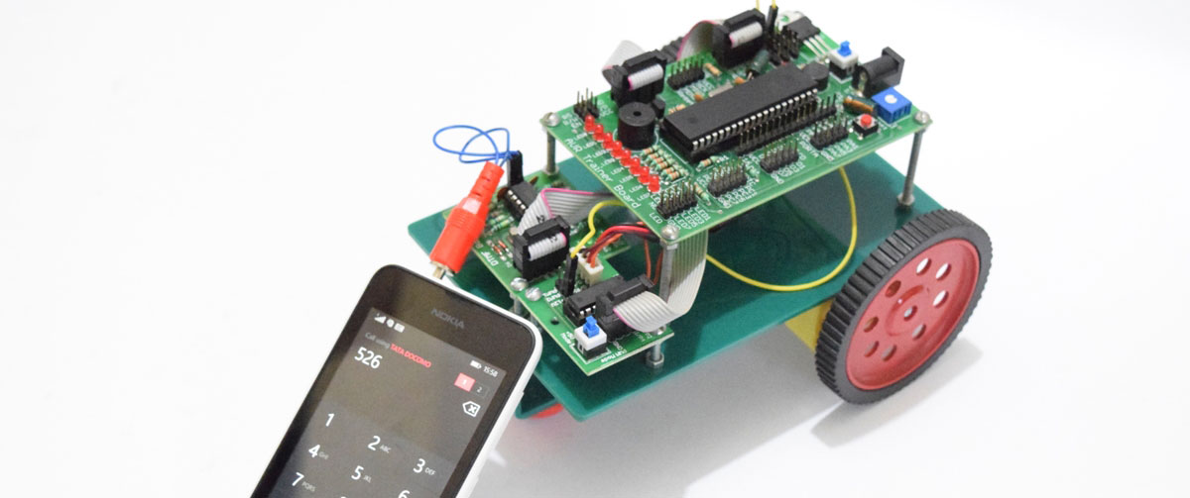

Figure 1.1-Circuit Image

1.3 Objective-

The objective of our project is to design build and program a cell phone controlled robotic vehicle.

Our robot is controlled by a cell phone, through this we can make our robot communicate on large scale over a large distance even from different cities.

1.4 Methodology-

* The methodology used is DTMF technology.
* DTMF-Dual Tone Multi Frequency.
* Multi frequency is group of signaling method that use a mixture of two pure tones.

**1.4.1 Circuit Design**

* The important components of this robot are DTMF decoder, Microcontrontroller and motor driver.
* An MT8870 series DTMF decoder is used here. All types of the mt8870 series use digital counting techniques to detect and decode all the sixteen DTMF tone pairs in to a four bit code output.
* The built in dial tone recognitiontion circuit eliminated the need for pre- filtering. When the input signal given at pin2 (IN-) single ended input configuration is recognized to be effective, the correct four bit decode signal of the DTMF tone is transferred to Q1 (pin11) through Q4(pin14) outputs.
* The atmega 16 is a low power; 8 bit microcontroller based on the AVR enhanced RISC architecture.
* All the 32 registers are directly connected to the arithmetic logic unit, allowing two independent registers to be accessed in one signal instruction executed in one clock cycle. The resulting architecture is more code efficient.
* Outputs from port pins PD0 through PD3 and PD7 of the microcontroller are fed to inputs IN1 through IN4 and enable pins (EN1 and EN2) of motor driver L293d respectively, to drive geared motors. Switch S1 is used for manual reset.

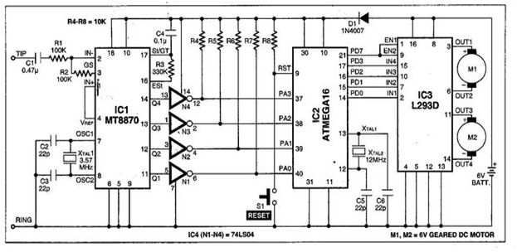

Figure 1.2-Circuit Diagram

**1.4.2 Working-**

In order to control the robot, you need to make a call to the cell phone attached to the robot (through head phone) from any phone, which sends DTMF tunes on pressing the numeric buttons. The cell phone in the robot is kept in ‘auto answer’ mode. If the mobile does not have the auto answering facility, receive the call by ‘ok’ key on the vehicle connected mobile end then made it in hands-free mode. So after a ring, the cell phone accepts the call.

Now you may press any button on your mobile to perform actions as listed below:

When you press 2 the robot will move forward

When you press 4 the robot will move left

When you press 8 the robot will move backwards

When you press 6 the robot will move right

When you press 5 the robot will stop.

The DTMF tones thus produced are received by the cell phone in the robot. These tones are fed to the circuit by the headset of the cell phone. The MT8870 decodes the received tone and sends the equipment binary number to the microcontroller, the robot starts moving.

When you press key ‘2’ (binary equivalent 00000010) on your mobile phone, the microcontroller outputs ‘10001001’ binary equivalent. Port pins PD0, PD3 and Pd7 are high. The high output at PD7 of the microcontroller drivers the motor driver (L293D).

Port pins PD0 and PD3 drive motors M1 and M2 in forward direction. Similarly, motors M1 and M2 move for left turn, right turn, backward motion and stop condition.

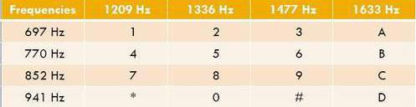

Figure 1.3- DTMF Table

The table shows how to compose any DTMF code. Each code, or "beep", consists of two simultaneous frequencies mixed together (added amplitudes). Standards specify 0.7% typical and 1.5% maximum tolerance. The higher of the two frequencies may have higher amplitude (be "louder") of 4 dB max.

This shift is called a "twist". If the twist is equal to 3 dB, the higher frequency is 3 dB louder. If the lower frequency is louder, the twist is negative.

Chapter 2: Literature Survey

1. Shaterian, K et al., [88] have reported a Goertzel Algorithm with a "Resource Sharing Approach by FPGA". Zhang Xinyi et al., [89] proposed "Modified Goertzel Algorithm for DTMF Signal Detection". From this paper Modified Goertzel Algorithm is effective than conventional Goertzel Algorithm. Details of algorithm simulation and algorithm, implementations are mentioned with a Table by Two Schemes i.e. Goertzel. Algorithm and Modified Goertzel Algorithm. The details of FFT in hardware using VHDL are measured with the help of Xilinx FPGA [90].

2. Kumar, A et al., [96] proposed "Network on Chip for DTMF Decoder and TDM Switching in Telecommunication Network with HDL Environment". It shows the eight bit information transport amid subscribers of two telephone interactions. The research work could be a significant attempt at full and programmable digitalization of switching contacts, in addition to witnessing a promotion for the VLSI industry [97-99].

3. Kumar, M et al., [108] proposed mobile phone operate robot using DTMF for Object Research. "Robot is controlled by mobile phone by DTMF technology through this, work is able to build robot move in desire direction by touchpad. This robot often more useful adding applications to it here a sensor is used which can detect object and adding a robotic arm to the robot which may place object & decide, decision spirit be taken by operator by providing reply of message sent by GSM module". Be able to provide information regarding objects near the metal property of the item that can be experienced by metal detector curl by hand on the robotic tip [109-110].

4. Li-Te Shen et al., [122] proposed new one for the DTMF detection. The customized DFT algorithm is engaged to notice the band pass DTMF signal. The computation prerequisite is extremely low than the well-known Goertzel algorithm. Also, the detection condition and rectification rates are still alike as DFT & Goertzel algorithm. Investigational outcome prove the good performance of the novel algorithm.

5. Selman, S et al., [120] proposes relative investigation of methods used to detect DTMF tones. While analog strategy rapidly replace by digital strategy, digital DTMF decoders by way of higher superiority become the idyllic replacement. These corresponding designs are studied here. Namely, DFT, filter design approach, Goertzel Algorithm & Sub Band Non-Uniform DFT. These algorithms are developed by MatLab. The execution part is completed by using a DSP, TMS320C6713.Here computational complexity & figure of merit are used as a presentation evaluate and in mutually cases the SB-NDFT is establish to be the finest.

6. Shatnawi, A. M et al., [121] proposes a digital sender for DTMF signals. This receiver is corresponding to the most favourable analog receiver. The conventional DTMF signal is passed during two set filters & eight extremely fine bands pass filters. This group of filters used to work out thresholds. The threshold estimations are explained. The planned receiver have extremely low prospect of inaccuracy still the incoming signal is rigorously masked in noise. This one is implemented using TMS 32010 congregation verbal communication and examines real time.

Chapter 3: Components used

**3.1 Diodes:-**

Diodes are components that allow current to flow in only one direction. They have a positive side (leg) and a negative side. When the voltage on the positive leg is higher than on the negative leg then current flows through the diode (the resistance is very low).

When the voltage is lower on the positive leg than on the negative leg then the current does not flow (the resistance is very high). The negative leg of a diode is the one with the line closest to it. It is called the cathode. The positive end is called the anode.

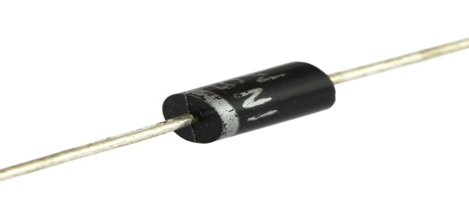

Figure 3.1-Diode

**3.2 LED:-**

Light Emitting Diodes are great for projects because they provide visual entertainment. LEDs use a special material which emits light when current flows through it. Unlike light bulbs, LEDs never burn out unless their current limit is passed. A current of 0.02 Amps (20 mA) to 0.04 Amps (40 mA) is a good range for LEDs. They have a positive leg and a negative leg just like regular diodes. To find the positive side of an LED, look for a line in the metal inside the LED. It may be difficult to see the line. This line is closest to the positive side of the LED. Another way of finding the positive side is to find a flat spot on the edge of the LED. This flat spot is on the negative side.

**3.3 Resistors:-**

A resistor is a passive two terminal component that implements [electrical resistance](https://en.wikipedia.org/wiki/Electrical_resistance) as a circuit element. In electronic circuits, resistors are used to reduce current flow, adjust signal levels, to divide voltages, [bias](https://en.wikipedia.org/wiki/Biasing) active elements, and terminate [transmission lines](https://en.wikipedia.org/wiki/Transmission_line), among other uses. High-power resistors that can dissipate many [watts](https://en.wikipedia.org/wiki/Watt) of electrical power as heat may be used as part of motor controls, in power distribution systems, or as test loads for [generators](https://en.wikipedia.org/wiki/Electric_generator). Fixed resistors have resistances that only change slightly with temperature, time or operating voltage. Variable resistors can be used to adjust circuit elements (such as a volume control or a lamp dimmer), or as sensing devices for heat, light, humidity, force, or chemical activity.

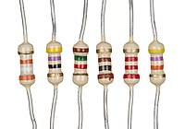

Figure 3.2- Resistors

In our project we have used resistors to limit the amount of current flow so that other devices are not affected.

**3.4 Capacitors:-**

The capacitor is a component which has the ability or “capacity” to store energy in the form of an electrical charge producing a potential difference (Static Voltage) across its plates, much like a small rechargeable battery. There are many different kinds of capacitors available from very small capacitor beads used in resonance circuits to large power factor correction capacitors, but they all do the same thing, they store charge.

When used in a direct current or DC circuit, a capacitor charges up to its supply voltage but blocks the flow of current through it because the dielectric of a capacitor is non-conductive and basically an insulator. However, when a capacitor is connected to an alternating current or AC circuit, the flow of the current appears to pass straight through the capacitor with little or no resistance.

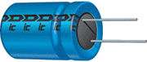  
Figure 3.3- Capacitor

There are two types of electrical charge, positive charge in the form of Protons and negative charge in the form of Electrons. When a DC voltage is placed across a capacitor, the positive (+ve) charge quickly accumulates on one plate while a corresponding and opposite negative (-ve) charge accumulates on the other plate. For every particle of +ve charge that arrives at one plate a charge of the same sign will depart from the -ve plate.

Then the plates remain charge neutral and a potential difference due to this charge is established between the two plates. Once the capacitor reaches its steady state condition an electrical current is unable to flow through the capacitor itself and around the circuit due to the insulating properties of the dielectric used to separate the plates.

The flow of electrons onto the plates is known as the capacitors **Charging Current** which continues to flow until the voltage across both plates (and hence the capacitor) is equal to the applied voltage Vc. At this point the capacitor is said to be “fully charged” with electrons.

In our project based on the charge and discharge timings of the Capacitor, a PWM Signal is generated at the OUT Pin.

**3.5 Volt Power Supply: -**

Most digital logic circuits and processors need a 5 volt power supply. To use these parts we need to build a regulated 5 volt source. Usually you start with an unregulated power supply ranging from 9 volts to 24 volts DC. To make a 5 volt power supply, we use a LM7805 voltage regulator IC (Integrated Circuit). The IC is shown below.

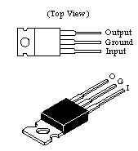

Figure 3.4- LM780

The LM7805 is simple to use. You simply connect the positive lead of your unregulated DC power supply (anything from 9VDC to 24VDC) to the Input pin, connect the negative lead to the Ground pin and then when you turn on the power, you get a 5 volt supply from the Output pin. This 5 volt output will be used in the following projects.

Connect the red wire from the power supply adapter to the input of the 7805. Connect the black wire from the power supply adapter to the ground row (with the blue line beside it). Run a black jumper wire from the ground row to the ground of the 7805. Then use a yellow jumper to connect the 5 V output to the row of holes with the red stripe beside it.

**3.6 DC MOTOR:-**

3.6.1 Introduction:

This page describes how DC motors work, and how we can use them to build the traction system of a robot. It covers both permanent magnet motors, and series wound motors (such as car starter motors). All motors require two magnetic fields, one produced by the stationary part of the motor (the *stator*, or *field*), and one by the rotating part (the *rotor*, or *armature*). These are produced either by a winding of coils carrying a current, or by permanent magnets. If the field is a coil of wire, this may be connected in a variety of ways, which produces different motor characteristics.

3.6.2 Motor principles:

The basic law of a motor, the reason why they rotate, is governed by Fleming’s left hand rule (see figure below). This tells you the direction of the force on a wire that is carrying current when it is in a magnetic field.

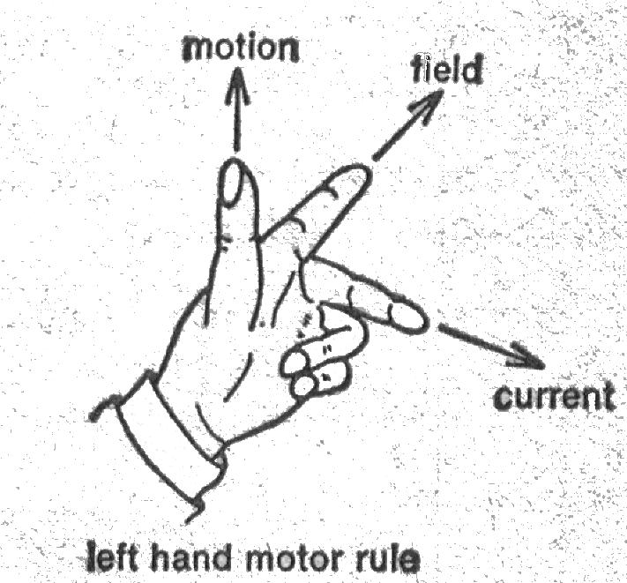

Figure 3.5-Left hand rule

**3.7 Crystal Oscillator:-**

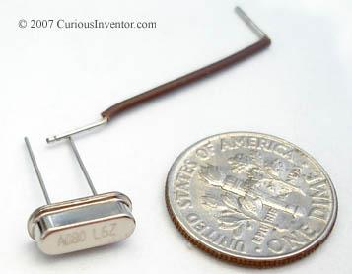

Figure 3.6- Crystal Oscillator

**3.7.1 Short description:-**

Crystals are commonly used to provide a stable clock source for micro-controllers. This has a freq. tolerance of +-50ppm, temperature stability of +-50ppm, and load capacitance of 18pF. It's slightly more than 1/8" tall.

**3. 8 Program Code :-**

//include header files

#include<reg52.h>

#include<stdio.h>

//define the motor conditions

#define lt 0x06;

#define rt 0x09;

#define st 0x0a;

#define stop 0x00;

#define rev 0x05;

unsigned int a;

void main()

{

while(1)

{

a=P0&0x0f;

if(a==0x02)

{

P2=st;

}

if(a==0x08)

{

P2=rev;

}

if(a==0x04)

{

P2=lt;

}

if(a==0x06)

{

P2=rt;

}

if(a==0x05)

{

P2=stop;

}

}

}

Chapter 4: Results and Discussion

By programming the microcontroller the robot will move on pressing the keys on mobile phone. DTMF tone is received by the mobile that is connected to the robot. We can drive the motor in backward, forward, right, left and stop condition. Thus the design and implementation of experiments to test the feasibility of using the Dual Tone Multi-Frequency encoding scheme as a method for communicating simple messages has been successful in controlling the robot wirelessly.

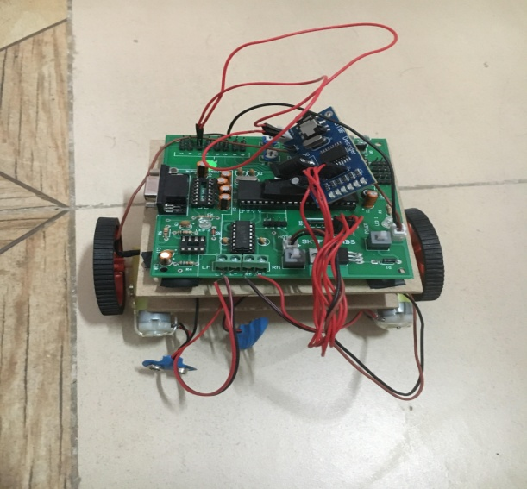

Figure 4.1-Working Model

**4.1`Working Of Implemented System:-**

* Mobile phone which is connected to the robot is kept in auto receiving mode.
* For the control of robot, we have to make a call to the mobile phone which is attached to the robot using earphone. thus two mobile phone are connected via mobile network.
* When the call is received then press the button in your mobile.
* DTMF tone is received by the mobile that is connected with the robot through headphone.
* These signals are received by the DTMF decoder that decodes the signal in binary sequence to the microcontroller. Sequences are given in table 1
* Due to the programming in controller robot will move when pressing key in the mobile.
* Microcontroller outputs are in binary form. The high output of the controller drives the motor driver to drive the motor in forward direction.
* Similarly we can move the motor in backward, left, right motion and stop condition.
* According to the source code given here key 2 is for forward, key 4 is for left rotation, key 6 is for right rotation, key 8 for reverse rotation in this robot navigation.
  1. **Block Diagram:-**

The robot receives this DTMF tone with the help of phone stacked in the robot. The received tone is processed by the atmega16 microcontroller with the help of DTMF decoder MT8870. The decoder decodes the DTMF tone in to its equivalent binary digit and this binary number is send to the microcontroller. The microcontroller is preprogrammed to take a decision for any give input and outputs its decision to motor drivers in order to drive the motors for forward or backward motion or a turn.

Figure 4.2-Block Diagram

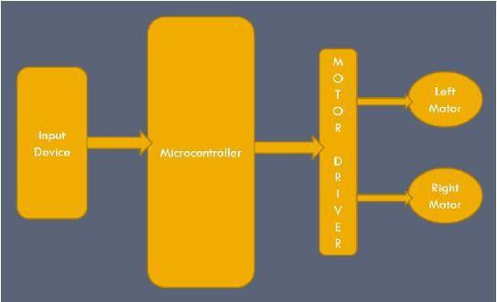

* 1. **Advantages:-**

DTMF’s technology is simple, low cost, as well as its already popular status in the telephone industry of today.

In the networks there are large numbers of nodes that are very simple and act merely as relay stations.

In healthcare (hospital and home environments), a robot that is capable of sending acoustic commands to turn on/off devices such as light switch or closing door while letting the user know that the process is taking place will be very helpful in allowing the user to feel more comfortable around robots..

* 1. **Applications:-**

**1. Scientific**

Remote control vehicles have various scientific uses including hazardous environments, working in the deep ocean, and space exploration. The majority of the probes to the other planets in our solar system have been remote control vehicles, although some of the more recent ones were partially autonomous. The sophistication of these devices has fuelled greater debate on the need for manned spaceflight and exploration.

**2. Military and Law Enforcement**

Military usage of remotely controlled military vehicles dates back to the first half of 20th century. Soviet Red Army used remotely controlled Teletanks during 1930s in the Winter War and early stage of World War II

**3. Search and Rescue**

UAVs will likely play an increased role in search and rescue in the United States. This was demonstrated by the successful use of UAVs during the 2008 hurricanes that struck Louisiana and Texas.

Chapter 5: Conclusion

By developing this robotic vehicle, we have overcome the drawbacks of RF communication which have a limited range whereas this car can be controlled from anywhere just using this DTMF technology. In these project with the use of a mobile phone for robotic control can overcome these limitations. It provides the advantages of robust control, working range as large as the coverage area of the service provider, no interference with other controllers and up to twelve controls. Although the appearance and capabilities of robots vary vastly, all robots share the features of a mechanical, movable structure under some form of control.

Future Scopes

**IR Sensors**

IR sensors can be used to automatically detect & avoid obstacles if the robot goes beyond line of sight. This avoids damage to the vehicle if we are manoeuvring it from a distant place.

**Password Protection**

Project can be modified in order to password protect the robot so that it can be operated only if correct password is entered. Either cell phone should be password protected or necessary modification should be made in the assembly language code. This introduces conditioned access & increases security to a great extent.

**Alarm Phone Dialler**

By replacing DTMF Decoder IC CM8870 by a 'DTMF Transceiver IC’CM8880, DTMF tones can be generated from the robot. So, a project called 'Alarm Phone Dialler' can be built which will generate necessary alarms for something that is desired to be monitored (usually by triggering a relay). For example, a high water alarm, low temperature alarm, opening of back window, garage door, etc.

References

[1]. Awab Fakih, Jovita Serrao, “Cell Phone Operated

Robotic Car.” International Journal of Scientific &

Engineering Research, ISSN 2229-5518.

[2]http://www.8051projects.info/

[3]http://www.dialabc.com/sound/dtmf.html

[4]http://www.robotplatform.com/howto/L293/motor_

driver_1.html

[5]http://www.atmel.in/devices/ATMEGA328.aspx

[6]Datasheet MT8870 Zarlink Semiconductor page 6.

[7] https://www.researchgate.net/